**TESTIMONIALS**

**Programme: MSc. Fashion Design and Merchandising**

**Department of Apparel & Fashion Design**

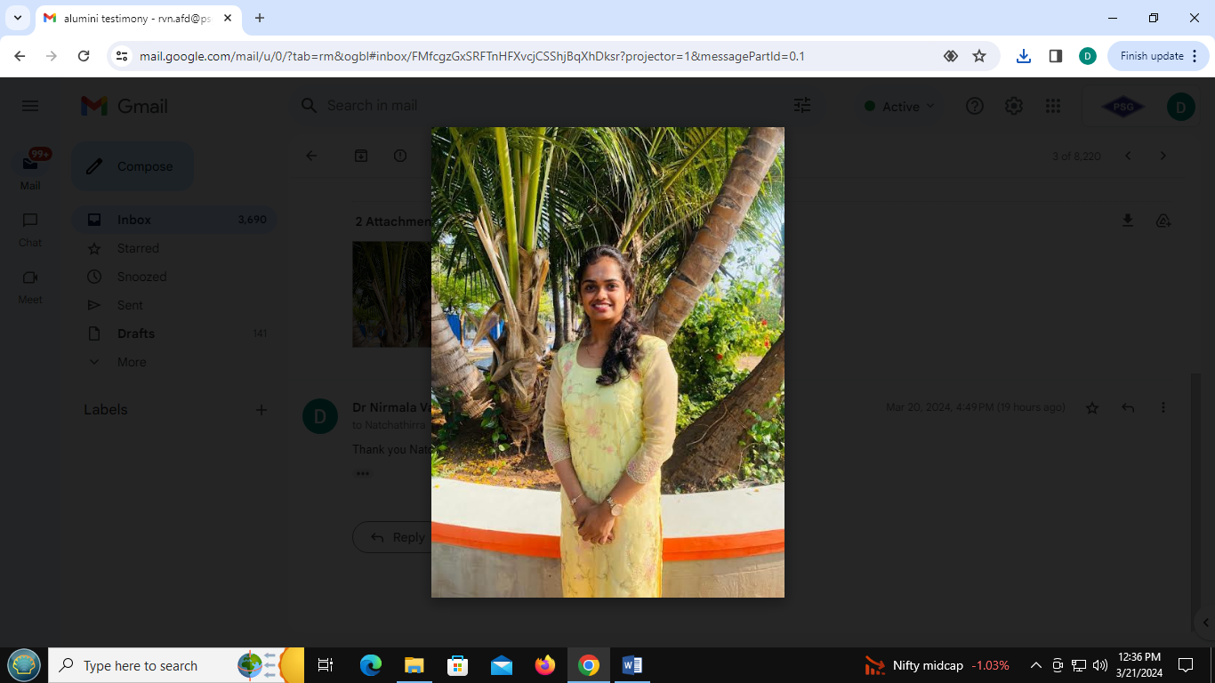

**Natchathirra S.**

Founder- NIRRA studio, Tiruppur

M.Sc FDM (2018 – 2023)

My experience at PSG College of Technology was instrumental in paving the way for me to launch my own brand. The education I received there wasn't just about textbooks and lectures—it was an immersive journey that prepared me for the real-world challenges of entrepreneurship. From day one, The AFD department fostered an environment of innovation and excellence. The curriculum wasn't just theoretical; it was practical and hands-on, giving me the skills and knowledge I needed to succeed in the competitive world of business. The faculty were more than just teachers; they were mentors who guided me every step of the way. Their expertise and real-world experience were invaluable as I navigated the complexities of starting my own brand. Moreover, the college provided a range of resources and opportunities for budding entrepreneurs. Whether it was through workshops, networking events, or access to cutting-edge facilities, institutions offered the support I needed to turn my ideas into reality. Perhaps most importantly, PSG instilled in me a sense of confidence and resilience. Through projects, internships, and industry collaborations, I learned to tackle challenges head-on and adapt to changing circumstances—a skill that has been crucial in my entrepreneurial journey. As I look back on my time at PSG College of Technology, I'm filled with gratitude for the role it played in shaping my entrepreneurial path. The education and support I received there have been invaluable assets as I continue to grow and expand my brand.

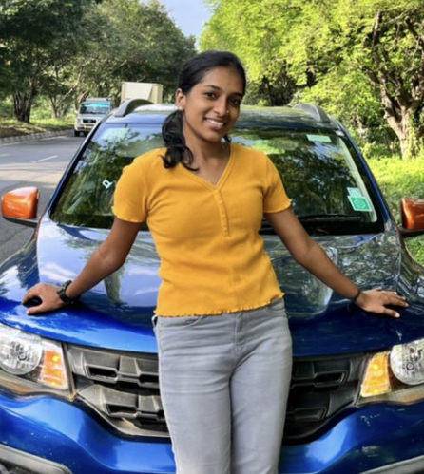

**Akshaya A. S.**

Production Leader Quality, M/s Prodin Sporting Goods, Decathlon, Coimbatore

M.Sc FDM (2017 – 2022)

Studying at PSG College of Technology was a pivotal experience in my life. From the moment, I stepped onto the campus, I knew that I was in for a transformative experience. I was excited to meet new people, learn from knowledgeable professors, and explore all that the college had to offer. I was particularly impressed by the amount of hands-on experience that was available. In addition to lectures, we had the opportunity to participate in lab experiments and projects that gave us a deeper understanding of the courses. I had the chance of meeting people from diverse backgrounds and interests, which helped me broaden my perspectives.  It was amazing to be surrounded by individuals who were just as passionate about learning as I was overall, my experience at PSG College of Technology was one that I will never forget. I am grateful for the opportunities I had to learn, grow, and connect with others. As I move forward in my career, I will always carry the lessons and memories that I had at PSG Tech.

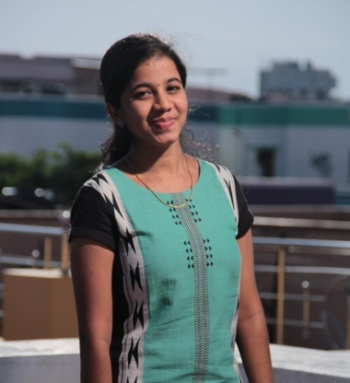

**Sabitha R.**

Production Planner, M/s Oshadi Collective, Chithode, Erode

M.Sc FDM (2017 – 2022)

I was a person who didnot have any idea about my career after schooling. I got my admission in M.Sc Fashion Design and Merchandising Programme at PSG Tech and that's the turning point that happened in my life. 5 years of my college life taught me to manage all my responsibilities and still make time for the things I enjoy. The courses taught me in M.Sc FDM helped me to grow into a more confident person. I have learned to trust my own judgment and to stand up for myself when necessary. The main reason behind this is the selfless faculty who put all their efforts in sowing the seeds of knowledge which became a tree with strong roots. I am incredibly grateful to be a part of the Department of Apparel and Fashion Design and PSG TECH family.

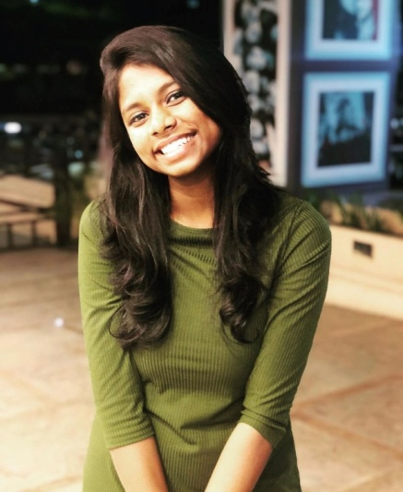

**Abirami Ashok Kumar S.**

Designer & Proprietor, M/s The Bee Label, Coimbatore  
M.Sc FDM (2016-2021)

I have always believed that the environment is the key to success. When you are not surrounded by the right people your goal will be delayed by 50%, so that's how crucial PSG Tech is for me and my milestones. My vision turned into the reality of becoming a fashion designer when I took up the 5 year integrated M.Sc. Fashion Design and Merchandising programme. Though it was a huge step towards building a strong career yet the fear of studying 5 years straight in a row kept me petrified. But it turned out to be the place where I understood myself and learned some life lessons, enriched by the constant guidance that was provided with efficient training. The department of Apparel and Fashion Design has nourished me with great knowledge through the supporting faculties and immense fun with my energetic peers. This college and the department have provided us with the platform to build our character by enhancing our leadership and negotiation skills through various forum activities and events. It has the best curriculum that involves not just theoretical lectures but a lot of experimental and explorative opportunities to make learning more interesting, as well as to connect with new personalities which definitely will help groom one's future. This sure has been an amazing 5 years in my life and I owe a lot to PSG College of Technology for who I am today.

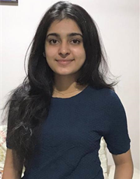

**Nivedha C.**

Fashion Designer, M/s PH Project, Coimbatore  
M.Sc FDM (2016-2021)

I have always wanted to be the best and so I chose to learn from the best. But when I entered PSG Tech, I was shocked. Guess what, it had more than what I expected. It was a great experience for me studying in PSG Tech. You laugh, you cry, you learn and you win. That’s exactly what happens here. All the faculties have been so friendly and keen on bringing out the talents of fellow students. The five years at PSG Tech helped me to realize my skills and nourish them. Especially I’ve created a good network with lots of personalities which are really important in one’s life.

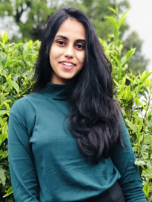

**Ragamalya M.**

Designer, M/s Kolour Koncepts International, Bengaluru.

M.Sc FDM (2016-2021)

PSG College of Technology, an institution where studies are perfectly balanced with extracurricular activities helped me to reach heights of success in every field. Professors are all experts in their respective fields thus enables us to be technically sound in our area of interest. The curriculum was challenging and the completion of work had offered a valuable insight and hands on experience in real world. Thus by providing a cross functional platform, PSG college of technology is one of the superlative choice for college.

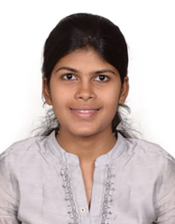

**Kaviya Prabha V.**

Proprietor, M/s Vyara Bridal studio, Tiruppur  
M.Sc FDM (2016-2021)

The 5 Year Integrated M.Sc Fashion Design and Merchandising is a very creative program equipped me with knowledge and skills to become an entrepreneur. The variety in teaching content and interactive sessions made the while experience of my 5 years more interesting and inspiring. The golden part in the program is the internship, where I gained the practical knowledge and experience in the industry, which is exquisitely coordinated. The faculty were friendly and helped me to shape my career path. My experience in my department of Apparel and Fashion Design at PSG Tech is an unforgettable memory. It was an overall experience of fun, joy, wisdom & pride

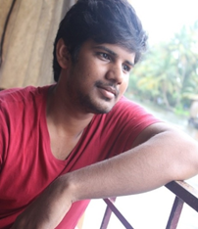

**Mithun Raaju T.S.K.**

Production leader industrialization and Quality, M/s Decathlon Prodin Sporting Pvt. Ltd., Mysore.

M.Sc FDM (2015-2020)

“PSG College of Technology” always proves to be the top-ranking college in providing knowledge as well as guiding students towards a positive living. I am so grateful to the wonderful faculty of the Apparel and Fashion Design Department who groomed me a lot in enhancing my skills and placing me in a better position. My education from PSG College of Technology has allowed me to begin a successful and fulfilling career at Decathlon Company. I owe huge respect, love, and devotion to entire faculty members and the department. It's their efforts that make me count myself as a better professional. I am thankful to Training & Placement cell for providing a platform to enhance my skills and an opportunity to showcase them. Thanks to the department for helping me to get placed for moving into my successful career.

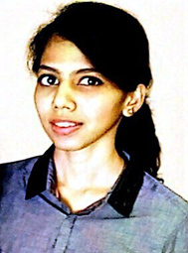**Aathirai S.**

Designer, M/s Sri Anokha Design Studio, Tiruppur.  
M.Sc FDM (2015-2020)

Choosing M.Sc. Fashion Designing and Merchandising is one of the best decisions of my life. Though initially, I was skeptical about the course, since we were the first batch and I wasn’t into designing, day by day, year by year, it proved me wrong because Fashion Design and Merchandising is more than just a normal designing course. It is a carefully put-together cusp of production, design, and management by experts. We have an amazing panel of faculty from whom I learnt so much more than just the curriculum, including, time management, professionalism, leadership, and interpersonal skills, all of which are crucial for both professional and personal growth. We have industrial visits, cluster visits, and complete internships in two semesters (seventh and tenth to be precise) all of which mould us into professional individuals by honing the key skills required by the industries. Overall, it’s a blue-chip course designed to not only teach everything you need to know but lead you in the right direction to be able to succeed. Altogether, the complete learning from the course made me strive as a successful entrepreneur now.